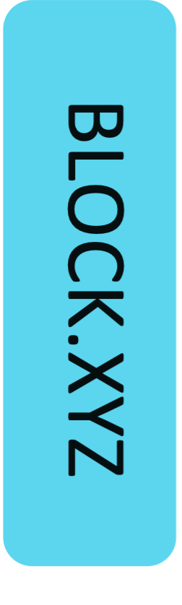

Data Engineering

Candidate Interview Prep Guide

How we interview

We strive to make our interview process a true reflection of our culture: transparent, mindful, and collaborative. Throughout the interview process, your recruiter will partner closely with you and guide you through next steps.

Interview Accommodations

We’re committed to an inclusive interview experience, including providing reasonable accommodations to disabled applicants [[here](https://thebodyisnotanapology.com/magazine/i-am-disabled-on-identity-first-versus-people-first-language/) is some context on why we use identity-first language in this instance].

Block is open to hiring people with different backgrounds, including disabilities. Please don’t hesitate to let a team member know of any necessary accommodations.

Contents

Section 01 Block Levels | Engineering Career Ladder

Section 02 Interview Process

Section 03 Preparing for your interview - Technical Screen

Section 04 Preparing for your interview - Virtual Onsite Interviews



# Block Levels

| **Level** | **L3** | **L4** | **L5** | **L6** | **L7+** |
| --- | --- | --- | --- | --- | --- |
| ***Criteria*** | ***A starting engineer professional*** | ***A solid contributor*** | ***A strong independent contributor*** | ***A team leader*** | ***An organizational leader*** |
| **Typical Experience** | Relevant Bachelor's degree (or equivalent practical experience). | Relevant Bachelor's degree (or equivalent practical experience) plus 2 years of relevant industry (or additional academic) experience. | Relevant Bachelor's degree (or equivalent practical experience) plus 5 years of relevant industry (or additional academic) experience. | Relevant Bachelor's degree (or equivalent practical experience) plus 8 years of relevant industry (or additional academic) experience. | Relevant Bachelor's degree (or equivalent practical experience) plus 12 years of relevant industry (or additional academic) experience. |
| **Scope and Impact** | Develops data engineering solutions with supervision and support. | Designs, develops, ships, and maintains engineering solutions with support. | Independently designs, develops, ships and maintains engineering solutions. | Leads medium-to-large features, multi-person efforts that usually cross engineering team boundaries. | Has a track record of leading strategic or complex initiatives that have a clear impact on the success of their organization. |
| **Ownership** | n/a | Responsible for the entire lifecycle of their code exclusive of the actual design including design docs: development, test, production launch, documentation, and maintenance. | Responsible for the successful delivery of their projects, including planning, risk management, design, development, testing, rollout, and maintenance.  Is responsible for improving the health and quality of code they are working on. | Responsible for the successful delivery of their projects, including coordination, planning, risk management, design, development, testing, rollout, and maintenance.  Responsible for the long term health and quality of their team’s codebase and systems. | Is responsible for the successful delivery and evolution of projects with organizational impact, including coordination, planning, rollout, and maintenance.  Is responsible for the long term architecture, health and quality of their organization's codebase and systems. |
| **Collaboration** | Collaborates within their team seeking support as needed. | Collaborates within their team seeking support as needed.  Collaborates with stakeholders with supervision. | Independently collaborates with stakeholders.  Collaborates within their team and with adjacent teams.  Practices and advocates data engineering standards and best practices. | Drives collaboration with their teammates, partners and stakeholders to advance team goals.  Fosters an environment of collaboration and knowledge sharing within their team.  Guides the technical direction of the team to ensure success.  Is a technical representative for their team’s systems.  Exemplifies and upholds data engineering standards and best practices within their team. | Drives collaboration across teams and disciplines to advance organizational goals.  Fosters an environment of collaboration and knowledge sharing within their organization.  Drives and influences the technical direction of their organization to ensure success of strategic initiatives.  Is a technical representative for systems that span multiple teams or have organizational impact.  Exemplifies and upholds data engineering standards and best practices within their organization. |

# Our Interview Process



|  |  |  |  |
| --- | --- | --- | --- |
| Technical Screen | Virtual Onsite Interviews | Hiring Bar | Offer Decision |
| * **Pair Programming** [45-mins]   + All candidates will complete a SQL screen   + Senior level candidates will complete an additional Python screen * After reviewing feedback with the hiring team, we’ll either recommend moving forward, an additional screen, or to not move forward at this time. | * **Data Modeling, ETL, & Data Architecture** [60-mins] * **Analytical Thinking** [45-mins] * **Business Partnering** [30-mins] * **DE Past Experience** [30-mins] * **Leadership**  [30-mins)]   + L5+ candidates only * **Hiring Manager Sync** [30-mins] * Please note depending on the specifics/nicheness of the role there may be additional interview loops added to the standard process | * Interview feedback is review by the data engineering leadership team * Final level decision is determined * Final approval for hire is determined | * With approval from the Hiring Bar, your recruiter will partner with you to extend an offer and navigate the offer process. |



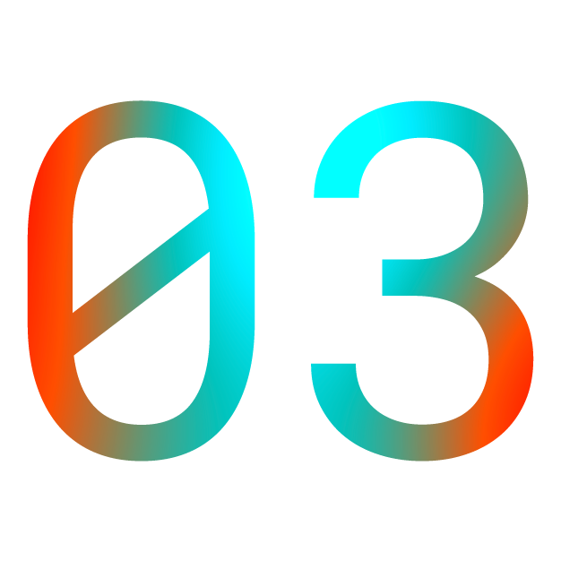

**Preparing for your interview**

## Technical Screen

**For L4 [mid level] candidates:**

* During the interview you’ll write and compile code in a collaborative online IDE [coderpad].
* The Purpose of this interview is to test your fluency and understanding of **SQL principles**.
* The screen covers SQL’s basic syntax and some aggregation and analytical functions.
* Generally speaking, SQL users at Square are most familiar with Snowflake SQL and MySQL but you are welcome to use any SQL flavor you are most comfortable with.

**For L5+ [senior level] candidates:**

* During the interview you’ll write and compile code in a collaborative online IDE [coderpad].
* The Purpose of this interview is to test your fluency and understanding of **SQL** principles and assess your basic knowledge and technical competencies of **Python** principles.
* The screen covers SQL’s basic syntax and some aggregation and analytical functions.
* The team will be evaluating your familiarity of solving a data issue programmatically, as well as, calibrating your understanding of data structures and algorithms.

**Areas Interviewers Assess:**

* Communication/Collaboration
* Analysis
* Troubleshooting
* Code Fluency
* Code Maintainability

**Tips for Success:**

* The interviewer wants to understand your approach to problem-solving and why you are making your decisions.
* Please walk us through what your assumptions are and the solutions you're choosing.
* Make sure you understand what the interviewer expects from you before attempting to solve the problem.
* Be sure to check out [interviewing.io](https://interviewing.io/) for a live paired programming session and brush up on DE computer science fundamentals.



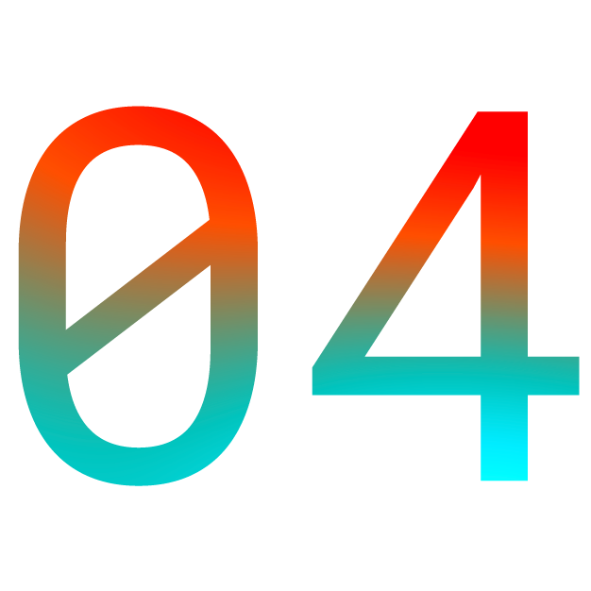

**Preparing for your interview**

## Virtual Onsite Interviews

**Q&A: Data Modeling, ETL, & Data Architecture [60-minutes]**

* The goal of this interview is to calibrate your skills on architecting data warehouses and designing data models as well as your ability to build efficient and scalable end to end data pipelines, from data ingestion, to debugging and analyzing root cause and data issues.

**Q&A: Analytical Thinking [45-minutes]**

* The goal of this interview is to assess your analytical skills. There will be questions about various business use cases. You are expected to ask appropriate followup questions to refine the requirement, determine the right analysis approach, identify the correct metrics, make business recommendations and visualize the results.

**Q&A: Data Engineering Past Experience [30-minutes]**

* The goal of this interview is to understand your technical contributions to projects. Talk about your past experience so that the interviewer can learn about your experiences, wins, challenges, and impact on teams. Hopefully we’ll get to go through a technical deep-dive into some of your past projects. This is not a coding interview.

**Q&A: Business Partnering [30-minutes]**

* The goal of this interview is to see how you will partner with various functions on the Marketing team. You are expected to discuss how you collaborated with business teams in your past experience. Specifically, how do you help the team prioritize and make decisions. Please be ready to discuss an example in detail.

**Q&A: Leadership [30-minutes]**

* The goal of this interview is for us to learn more about your leadership experience in detail. Specifically, you are expected to discuss how you propose, lead and influence cross-functional initiatives, advocate for changes to data infrastructure and tooling, as well as evangelize best practices within/outside of your immediate team.

**Role Alignment w/ Hiring Manager [30-minutes]**

* You will meet 1:1 with the Hiring Manager to learn more about the role, scope of work, and team. This is your opportunity to ask questions about what you’ve learned while speaking with the team and dive into any outstanding topics to ensure the opportunity is a fit for all parties involved.



Thank you for considering a career at Block, and for taking the time to interview with us!